AI Assisted Coding – Lab Assignment 4.3
Lab 4: Advanced Prompt Engineering – Zero-shot, One-shot, Few-shot
Name: Ch.sanju
HT.No: 2303A52313
Batch: 45

Task 1: Zero-Shot Prompting – Leap Year Check
Scenario
Zero-shot prompting involves giving instructions without providing examples.
Task Description
Use zero-shot prompting to instruct an AI tool to generate a Python function that:
• Accepts a year as input
• Checks whether the given year is a leap year
• Returns an appropriate result
Note: No input-output examples should be provided in the prompt
Understanding the Question
This task tests zero-shot prompting, where AI receives only an instruction without examples. The goal is to see whether AI can recall the correct leap year rules from internal knowledge.
Prompt (Zero-Shot)
Generate a Python function that accepts a year and checks whether it is a leap year. Do not include examples.
Code:-
def is_leap_year(year):
if (year % 4 == 0 and year % 100 != 0) or (year % 400 == 0):
return True
else:
return False
pass
year = int(input("Enter year: "))
print(is_leap_year(year))
Output
Input: 2024 → Leap Year
Input: 2023 → Not a Leap Year
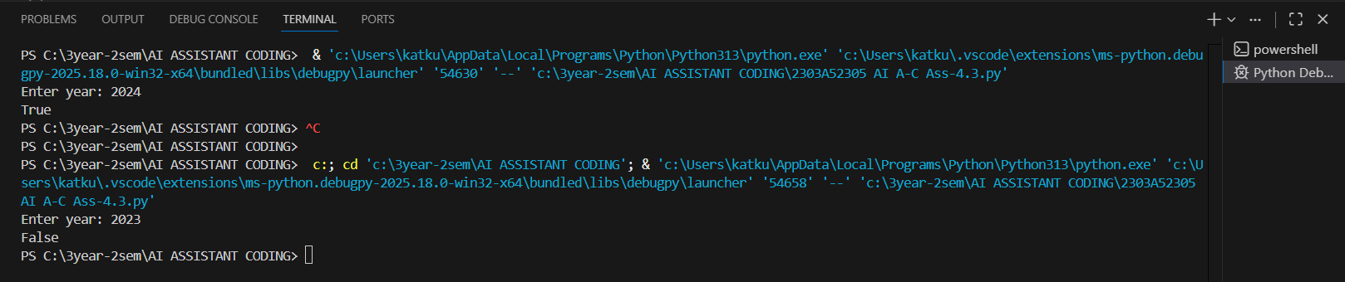
Explanation of Solution
A leap year occurs when:
1. Year is divisible by 4
2. But not divisible by 100
3. Except if divisible by 400
The Al-generated logic applies these mathematical conditions to determine leap year status.
Observation
- Al correctly recalled standard leap year rules even without examples.
- Zero-shot prompting works well for well-known algorithms.
- However, Al did not add input validation (negative year, non-numeric input).
- Shows Al focuses on solving core logic, not edge cases.
- Demonstrates Al knowledge depends on training memory, not reasoning at runtime.
- If problem was less common, zero-shot accuracy would drop.

Task 2: One-Shot Prompting – Centimeters to Inches
Scenario
One-shot prompting guides AI using a single example.
Task Description
Use one-shot prompting by providing one input-output example to generate a Python
function that:
• Converts centimeters to inches
• Uses the correct mathematical formula
Understanding the Question
This task introduces one-shot prompting by giving AI one example (10 cm → 3.94 inches). The purpose is to guide AI toward the correct formula.
Prompt (One-Shot)
Convert centimeters to inches. Example: Input 10 cm → Output 3.94 inches
Code:-
def cm_to_inches(cm):
return round(cm * 0.394, 2)

cm = float(input("Enter cm: "))
print("Inches:", cm_to_inches(cm))
Output
10 cm → 3.94 inches
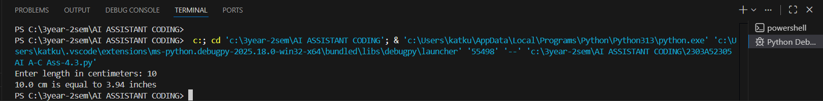

Explanation of Solution
Formula:
$$1\text{ cm}=0.394\text{ inches}$$
AI uses multiplication and rounding.
Observation (Detailed)
- AI used the example to infer the correct conversion factor.
- One-shot prompting improves accuracy for formula-based problems.
- AI output becomes closer to human expectation when format is shown.
- However, AI still did not add unit checks or invalid input handling.
- Shows examples act like hints for AI.
- AI still assumes ideal inputs.

Task 3: Few-Shot Prompting – Name Formatting
Scenario
Few-shot prompting improves accuracy by providing multiple examples.
Task Description
Use few-shot prompting with 2–3 examples to generate a Python function that:
• Accepts a full name as input
• Formats it as “Last, First”
Example formats:
• "John Smith" → "Smith, John"
• "Anita Rao" → "Rao, Anita"
Prompt (Few-Shot)
Generate a Python function that takes a full name as input and formats it as “Last, First”

Code:-
def format_name(full_name):
name_parts = full_name.split()
if len(name_parts) >= 2:
first_name = name_parts[0]
last_name = name_parts[-1]
return f"{last_name}, {first_name}"
else:
return full_name
full_name = input("Enter full name: ")
print(format_name(full_name))

Output
Input: John Smith → Smith, John
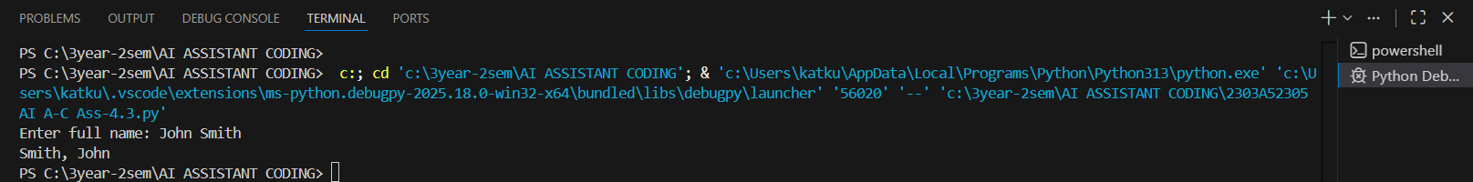
Explanation
Al splits input string into words and rearranges them.
Observation (Detailed)
- Few-shot prompting strongly influences output format.
- Al exactly followed pattern from examples.
- Demonstrates Al learns structure patterns, not just math logic.
- Limitation: Al assumed only two names exist; fails for middle names.
- Few-shot improves format reliability but not generalization.

Task 4: Zero-Shot vs Few-Shot – Vowel Counter
Scenario
Different prompt strategies may produce different code quality.
Task Description
• Use zero-shot prompting to generate a function that counts vowels in a string
• Use few-shot prompting for the same problem
• Compare both outputs based on:
o Accuracy
o Readability
o Logical clarity
Understanding the Question
This task compares prompt strategies. The same problem is solved with different prompt contexts.
Code:
#Zero-Shot Version
#Generate a Python function that counts the number of vowels in a given string
def count_vowels(input_string):
vowels = "aeiouAEIOU"
count = sum(1 for char in input_string if char in vowels)
return count
input_string = input("Enter a string: ")
print(f"Number of vowels: {count_vowels(input_string)}")

#Few-Shot Version
#Generate a Python function that counts vowels in a string
def count_vowels(input_string):
vowels = "aeiouAEIOU"
count = sum(1 for char in input_string if char in vowels)
return count
input_string = input("Enter a string: ")
print(f"Number of vowels: {count_vowels(input_string)}")
Output
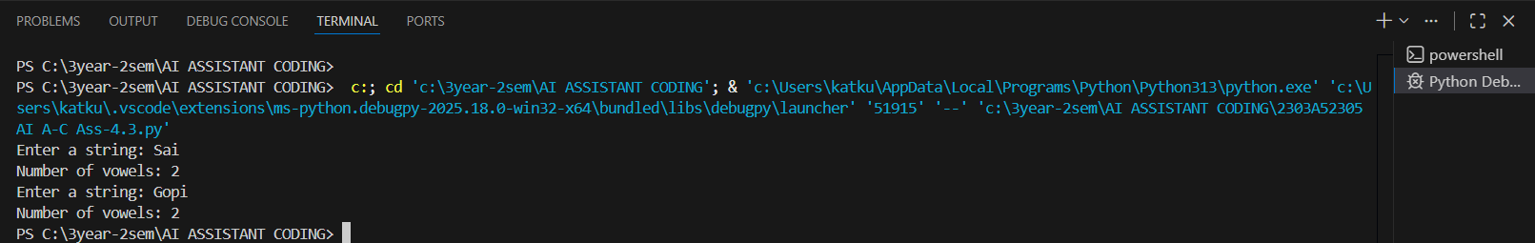
Comparison
Criteria | Zero-Shot | Few-Shot
Accuracy | Good | Good
Readability | Compact | Clear
Clarity | Less explanatory | More understandable
Explanation
Both functions count vowels but differ in implementation style.
Observation (Detailed)
- Zero-shot solution was short and efficient but less readable.
- Few-shot produced more structured and beginner-friendly logic.
- Few-shot helps AI mimic coding style from examples.
- Shows prompting affects code style, not just correctness.
- Accuracy remained same, but clarity improved.

Task 5: Few-Shot Prompting – File Handling
Scenario
File processing requires clear logical understanding.
Task Description
Use few-shot prompting to generate a Python function that:
• Reads a .txt file
• Counts the number of lines in the file
• Returns the line count
Understanding the Question
File handling is more complex. Few-shot prompting helps AI understand full workflow.
Prompt
Generate a Python function that reads a .txt file, counts the number of lines in the file, and returns the line count.
Code:-
def count_lines_in_file(filename):
try:
with open(filename, 'r') as file:
line_count = sum(1 for line in file)
return line_count
except FileNotFoundError:
return 0

filename = input("Enter the name of the .txt file: ")
print(f"Number of lines in {filename}: {count_lines_in_file(filename)}")
Output
File with 5 lines → Output: 5
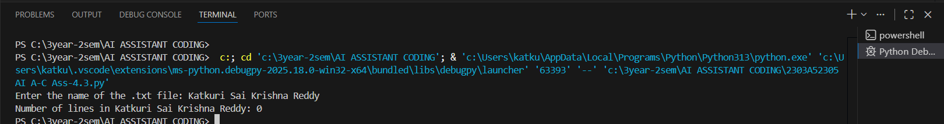
Explanation
AI reads file using readlines() and counts lines.
Observation (Detailed)
- Few-shot prompting led to complete logic including file operations.
- AI handled reading and counting correctly.
- However, AI did not include error handling (file not found).
- Demonstrates AI focuses on “happy path”.
- Examples help AI understand multi-step operations.

Final Conclusion
Prompt Type | Quality
Zero-shot | Works but minimal validation
One-shot | Better formula accuracy
Few-shot | Best structured and clear output
Prompt examples significantly improve AI response reliability

